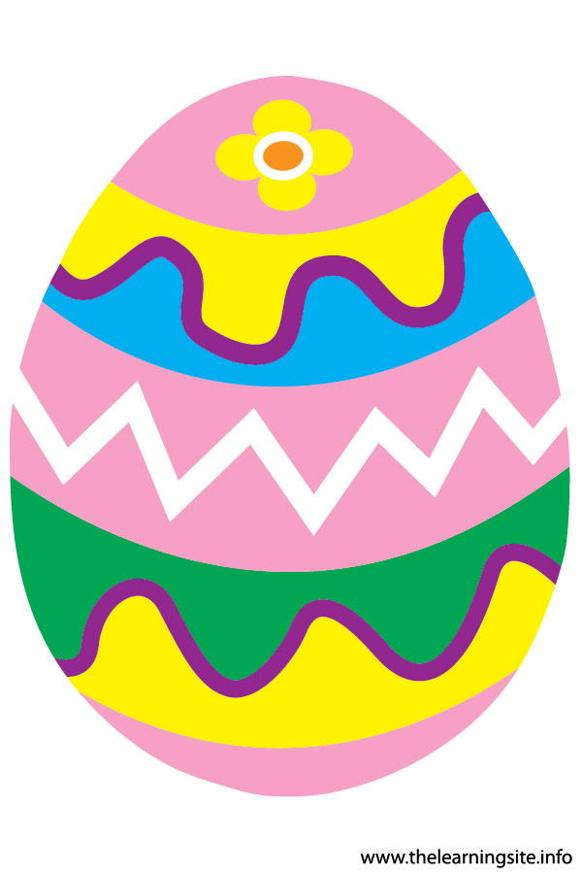
St Mark and St Swithun
Easter Craft Afternoon
Palm Sunday April 2nd
2:30-4:30

A fun time for children
aged 5-11 years

Craft activities with an Easter Eggstravaganza theme- including, decorating cakes, painting eggs, making baskets, bulb planting, making an Easter garden, and loads more………..

Places are limited – Book early to avoid disappointment.
St Mark’s Church Hall Church Road CR8 3QQ
Palm Sunday – 10th April 2022- 2:30-4:30
£5 per child to cover the cost of materials

Child’s name………………………………………...........
Age…………..
Address……………………………………… Post code…………..

Tel No:……………………….Any allergies…………………………

Contact name…………………………………………………….…
Relationship………………………………………………….………….
Emergency contact during event Number…………….………………
Name of person collecting ……………………………………………….
Payment Cheque to payable to St Marks PCC
bank transfer-A/c 26624214 – sort-60-06-14 –
stating Easter Crafts
I enclose a cheque / I transfered funds on

